EXPERIMENT 5 — Basic SQL Queries
AIM:
To execute basic SQL queries using SELECT, WHERE, BETWEEN, and LIKE conditions.
PROCEDURE:
- Display all vehicle records.
- Display petrol and diesel vehicles separately.
- Display vehicles based on price conditions.
- Use BETWEEN to find vehicles within a specified price range.
- Use LIKE to search vehicle names based on patterns.
- Display customers from Chennai.
- Display customers whose names start with A.
- Display showroom branches located in Chennai.
OUT: 1
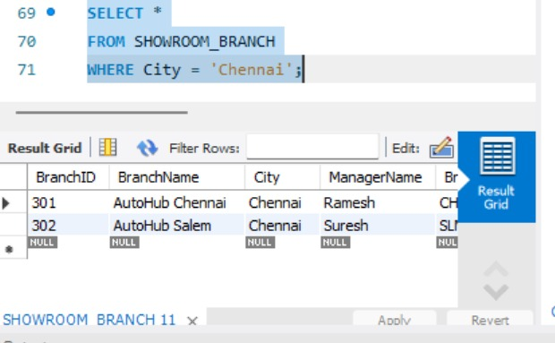
OUT : 2
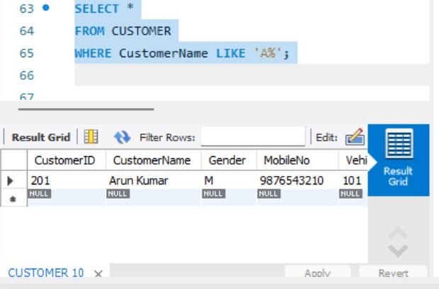
OUT: 3
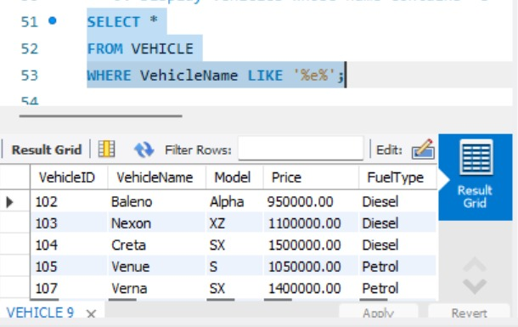
OUT : 4

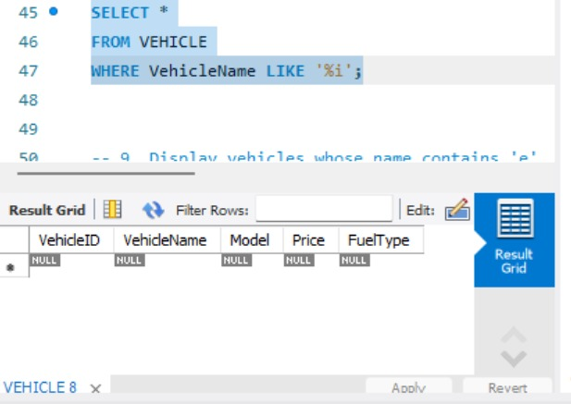
OUT : 5
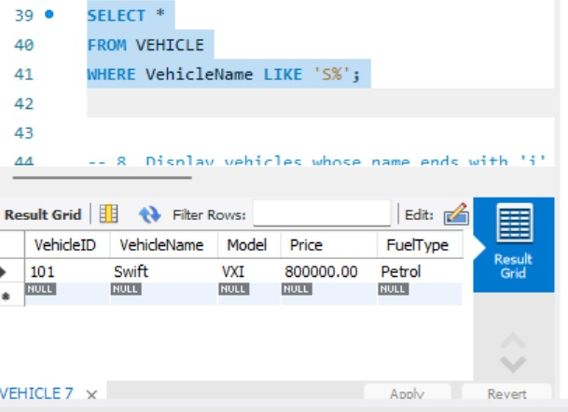
OUT : 6
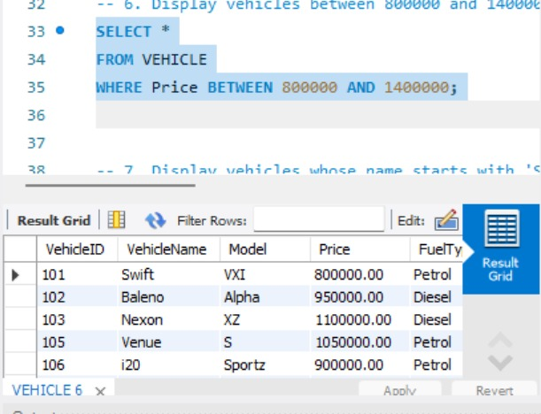
OUT: 7
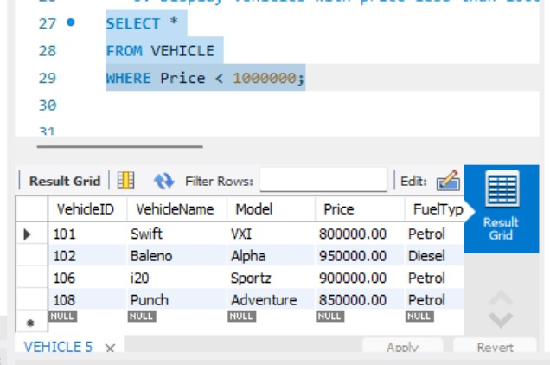
OUT : 7
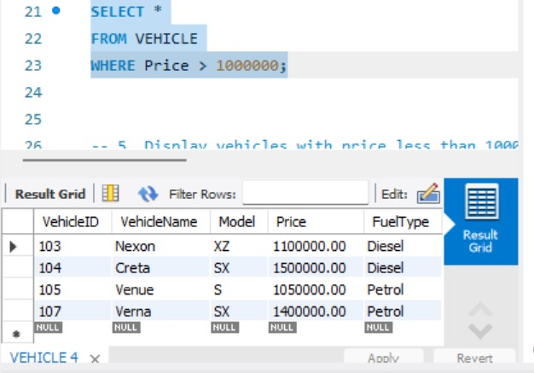
OUT : 8

OUT : 9
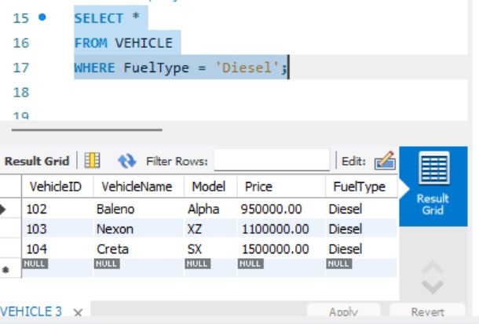
OUT : 10
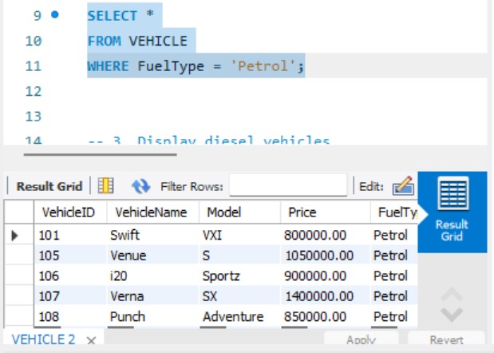
OUT : 11
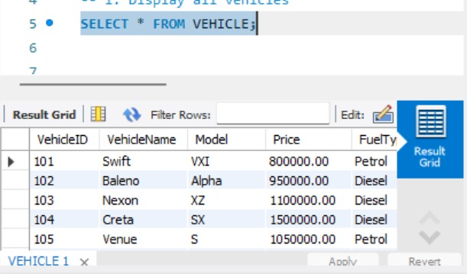

QUERY:
USE AUTOHUB_SHOWROOM;
-- 1. Display all vehicles
SELECT * FROM VEHICLE;
-- 2. Display petrol vehicles
SELECT *
FROM VEHICLE
WHERE FuelType = 'Petrol';
-- 3. Display diesel vehicles
SELECT *
FROM VEHICLE
WHERE FuelType = 'Diesel';
-- 4. Display vehicles with price greater than 1000000
SELECT *
FROM VEHICLE
WHERE Price > 1000000;
-- 5. Display vehicles with price less than 1000000
SELECT *
FROM VEHICLE
WHERE Price < 1000000;
-- 6. Display vehicles between 800000 and 1400000
SELECT *
FROM VEHICLE
WHERE Price BETWEEN 800000 AND 1400000;
-- 7. Display vehicles whose name starts with 'S'
SELECT *
FROM VEHICLE
WHERE VehicleName LIKE 'S%';
-- 8. Display vehicles whose name ends with 'i'
SELECT *
FROM VEHICLE
WHERE VehicleName LIKE '%i';
-- 9. Display vehicles whose name contains 'e'
SELECT *
FROM VEHICLE
WHERE VehicleName LIKE '%e%';
-- 10. Display customers from Chennai
SELECT *
FROM CUSTOMER
WHERE City = 'Chennai';
-- 11. Display customers whose name starts with 'A'
SELECT *
FROM CUSTOMER
WHERE CustomerName LIKE 'A%';
-- 12. Display showroom branches from Chennai
SELECT *
FROM SHOWROOM_BRANCH
WHERE City = 'Chennai';
RESULT:
Thus, various basic SQL queries were successfully executed using filtering and pattern-matching conditions.

